> library(deSolve)
> library(tibble)
> library(purrr)
> library(glue)
> library(dplyr)
> library(ggplot2)
>
> START<-0;FINISH<-100;STEP<-0.25
> simtime<- seq(START, FINISH,by=STEP)
> stocks<-c(sStock=100)
> auxs<-c(aCapacity=10000,aRef.Availability=1,aRef.GrowthRate=0.10)
>
> model<-function(time,stocks,auxs){
+ with(as.list(c(stocks,auxs)),{
+ aAvailability<-1-sStock /aCapacity
+ aEffect <-aAvailability /aRef.Availability
+ aGrowth.Rate <-aRef.GrowthRate *aEffect
+ fNet.Flow<-sStock *aGrowth.Rate
+ dS_dt <- fNet.Flow
+ return(list(c(dS_dt),NetFlow=fNet.Flow,
+ GrowthRate=aGrowth.Rate,
+ Effect=aEffect,
+ Availability=aAvailability))
+ })
+ }
> o <- data.frame(ode(y = stocks, times = simtime, func = model,
+ parms = auxs, method = "euler"))
> as_tibble(o)
# A tibble: 401 × 6
time sStock NetFlow GrowthRate Effect Availability
<dbl> <dbl> <dbl> <dbl> <dbl> <dbl>
1 0 100 9.9 0.099 0.99 0.99
2 0.25 102. 10.1 0.0990 0.990 0.990
3 0.5 105. 10.4 0.0989 0.989 0.989
4 0.75 108. 10.6 0.0989 0.989 0.989
5 1 110. 10.9 0.0989 0.989 0.989
6 1.25 113. 11.2 0.0989 0.989 0.989
7 1.5 116. 11.4 0.0988 0.988 0.988
8 1.75 119. 11.7 0.0988 0.988 0.988
9 2 122. 12.0 0.0988 0.988 0.988
10 2.25 125. 12.3 0.0988 0.988 0.988
# ℹ 391 more rows
# ℹ Use `print(n = ...)` to see more rows
> p1 <- ggplot(o,aes(x=time,y=sStock)) +
+ geom_point()+
+ geom_line()
> p1

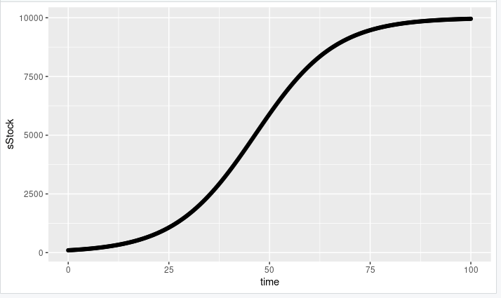

> p2 <- ggplot(o, aes(x = time, y = NetFlow)) +
+ geom_point() +
+ geom_line() +
+ labs(title = "NetFlow over Time", y = "NetFlow", x = "Time") +
+ theme_minimal()
> p2
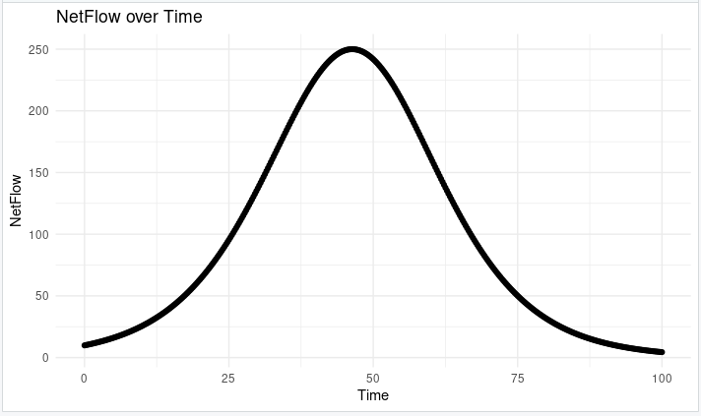

> p3 <- ggplot(o, aes(x = time, y = GrowthRate)) +
+ geom_point() +
+ geom_line() +
+ labs(title = "Growth Rate over Time", y = "Growth Rate", x = "Time") +
+ theme_minimal()
> p3

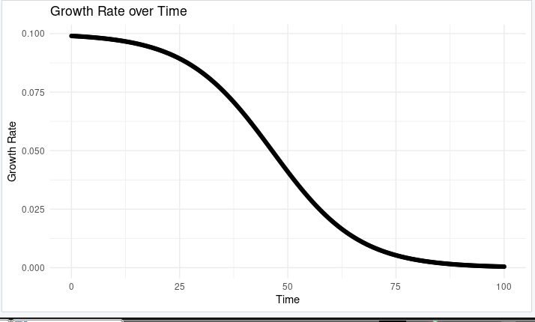
> p4_alt <- ggplot(o, aes(x = time, y = Availability)) +
+ geom_point() +
+ geom_line() +
+ labs(title = "Availability over Time", y = "Availability", x = "Time") +
+ theme_minimal()
> p4

